**Experiment No. 07**

**AIM: To Create Scrum Board for Scrum Master using JIRA Tool.**

**THEORY:**

# 1. Introduction to Scrum Boards in JIRA

A Scrum Board in JIRA is a visual management tool that helps teams manage their backlog, sprint planning, daily stand-ups, and sprint reviews. It represents the workflow of tasks from "To Do" to "Done" using columns and swimlanes.

2. **Understanding the Role of a Scrum Master in Relation to the Scrum Board**  The Scrum Master facilitates the Scrum process, ensures agile principles are followed, and helps the team stay organized. In JIRA, the Scrum Master customizes the Scrum Board to:

* Enable clear visibility of work.

* Support effective sprint planning.

* Monitor team performance and bottlenecks.

# 3. Key Components of a Scrum Board in JIRA

* **Columns**: Represent different stages of work (e.g., To Do, In Progress, Review, Done).

* **Swimlanes**: Group issues by priority, assignee, or epics.

* **Backlog**: A list of all tasks that are not yet assigned to a sprint.

* **Filters**: Define what issues appear on the board using JQL (JIRA Query Language).

* **Quick Filters**: Allow for quick views (e.g., show issues assigned to a specific team member).

# 4. Steps to Create a Scrum Board in JIRA Step 1: Access JIRA and Navigate to Board Creation

* Go to the JIRA dashboard.

* Click on "Boards" in the top navigation bar.

* Select "Create Board."

# Step 2: Choose the Board Type

* Scrum Board: Ideal for teams working in sprints.

* Choose "Scrum Board" and click "Next."

# Step 3: Select a Board Source

* From an Existing Project: If the team already has a project.

* From an Existing Filter: If you want to create a board based on specific JQL queries.

# Step 4: Configure Board Settings

* Name the board clearly (e.g., "Sprint Board – Team Alpha").

* Assign the board to the relevant project or filter.

# Step 5: Customize Columns and Swimlanes

* Go to "Board Settings" > "Columns" to adjust stages.

* Define workflows for each column (e.g., setting "In Review" before "Done").

* Use "Swimlanes" to organize issues by Epic, Assignee, or Priority.

**Step 6: Set Up Quick Filters**

* Add custom filters to view specific issues (e.g., "My Issues," "High Priority").

# Step 7: Manage Backlog and Sprints

* Enable the backlog view for effective sprint planning.

* Create and manage sprints, dragging issues from the backlog to the sprint.

# 5. Advanced Configurations

* **Card Layout**: Customize what information appears on each issue card.

* **Estimation**: Use story points or time estimates to track progress.

* **Work In Progress (WIP) Limits**: Set limits to prevent overloading the team.

# 6. Best Practices for Scrum Masters Using JIRA Boards

* Regularly review and update the board to reflect the current sprint status.

* Use filters and swimlanes to focus on critical issues during stand-ups.

* Encourage the team to update the board in real-time for transparency.

* Analyze board data to identify trends, blockers, and areas for improvement.

# 7. Monitoring and Reporting

* Utilize JIRA reports (burndown charts, velocity charts) to track sprint progress.

* Configure dashboards for high-level insights on team performance.

**Output:**

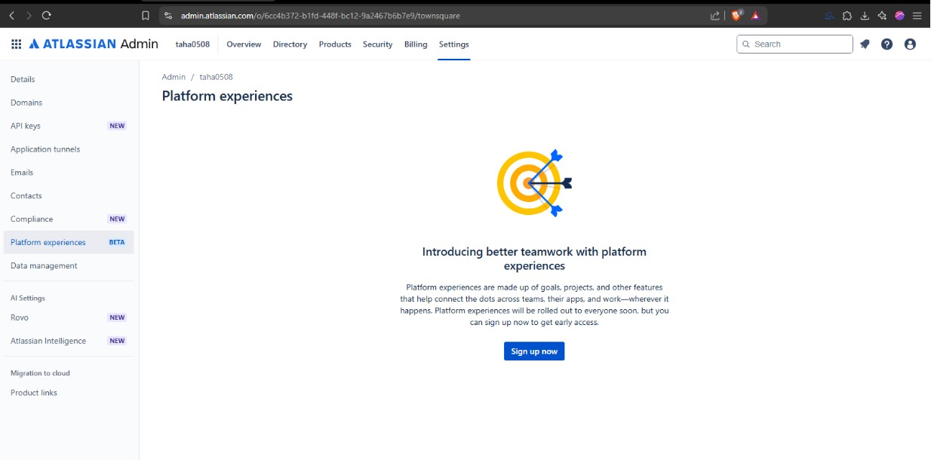

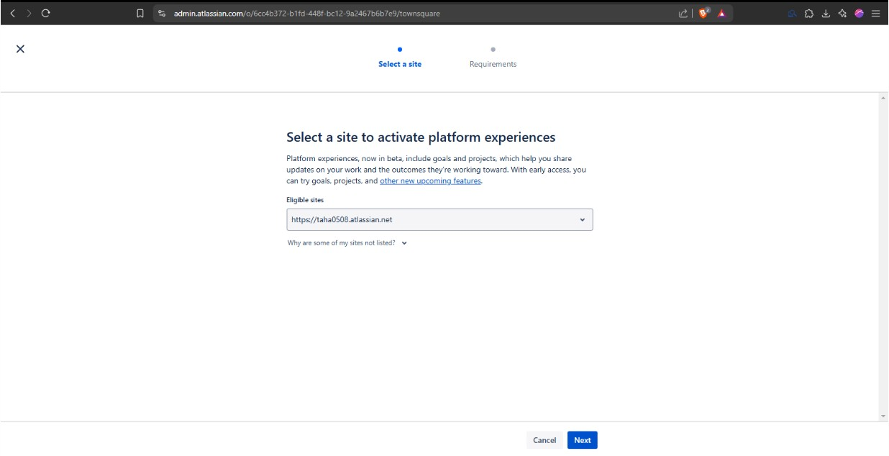

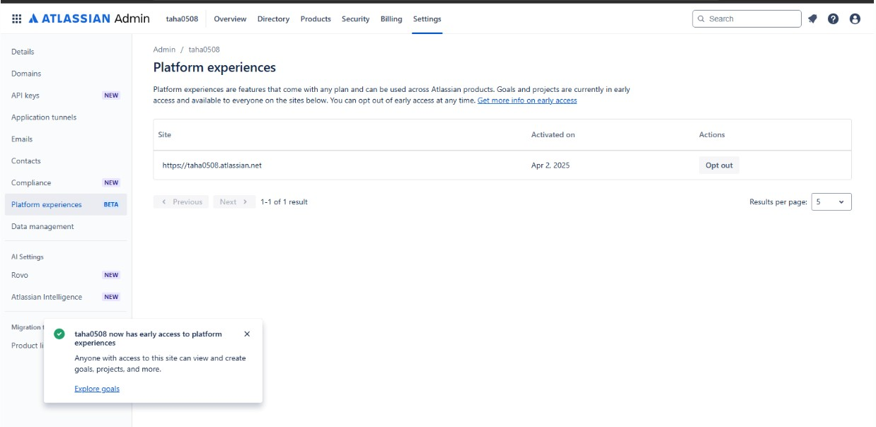

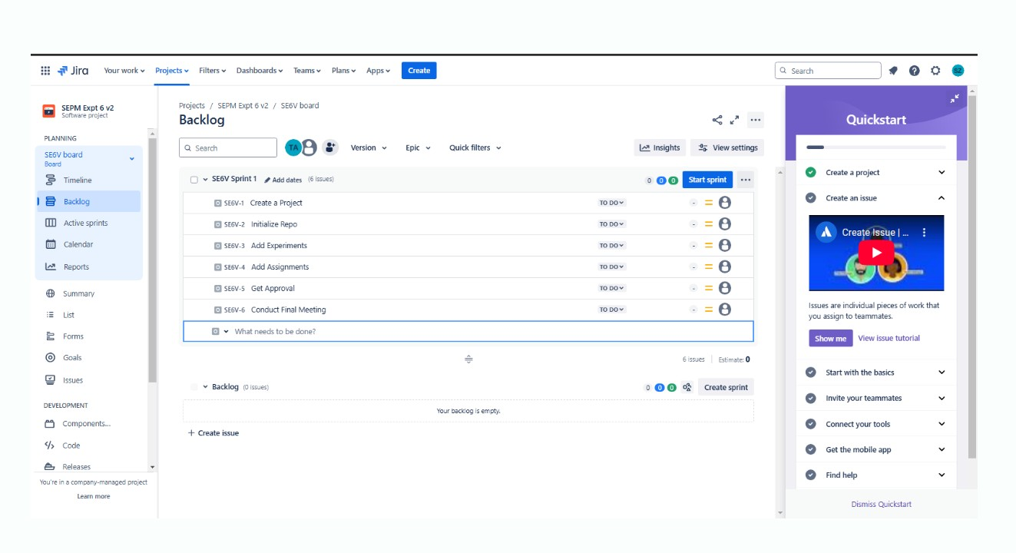

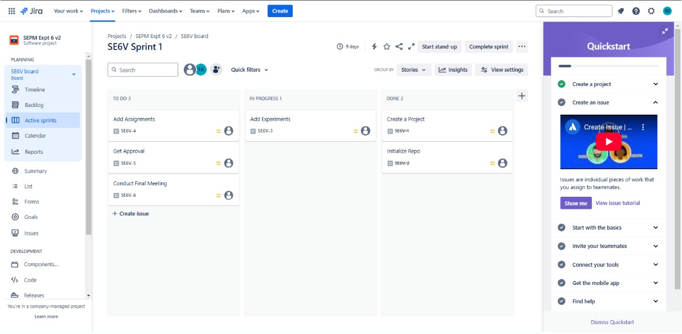

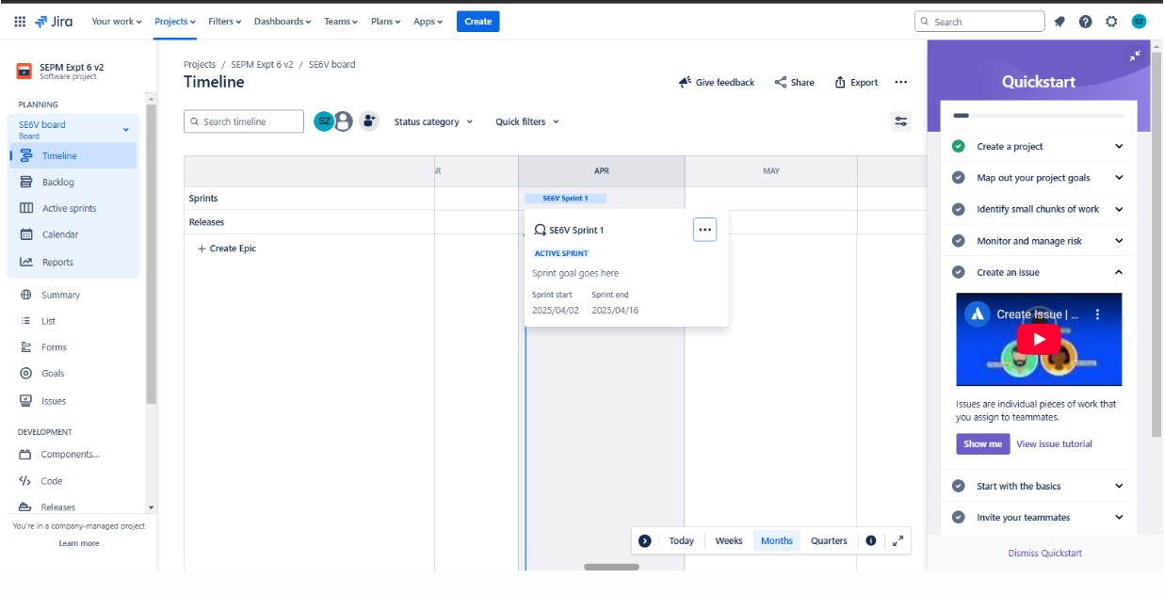

**CONCLUSION: Hence, we have successfully implemented a Scrum project using JIRA.**